**Artifical Intelligence and Deep Learning**

What is Machine Learning?

**Machine Learning** is the field of study that gives computers the capability to learn without being explicitly programmed. ML is one of the most exciting technologies that one would have ever come across. As it is evident from the name, it gives the computer that which makes it more similar to humans: ***The ability to learn***. Machine learning is actively being used today, perhaps in many more places than one would expect.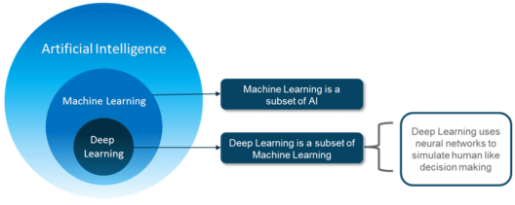

## **What is Artificial Intelligence ?**

Artificial Intelligence is nothing but the capability of a machine to imitate intelligent human behavior. AI is achieved by mimicking a human brain, by understanding how it thinks, how it learns, decides, and work while trying to solve a problem.

**For example:** A machine playing chess, or a voice activated software which helps you with various things in your iPhone or a Number plate Recognition system which captures the number plate of a over speeding car and processes it to extract the registration number and identify the owner of the car. All these wasn’t very easy to implement before **Deep Learning**. Now, let’s understand the various subsets of Artificial Intelligence.

# **Deep Learning Tutorial : Artificial Intelligence Using Deep Learning**

*Recommended by 206 users*

**

**

[Ashish Bakshi](https://www.edureka.co/blog/author/ashishbedureka-co/)

Published on Feb 18,2019

[10 Comments](https://www.edureka.co/blog/deep-learning-tutorial#disqus_thread)

27.6K Views

[Bookmark](https://www.edureka.co/blog/deep-learning-tutorial)

Email Post

Being an important subset of Machine Learning, the demand for [***Deep Learning Certification***](https://www.edureka.co/ai-deep-learning-with-tensorflow) has seen an immense rise, specially among those interested in unlocking the limitless possibilities of AI. Inspired by the growing popularity of Deep Learning, I thought of coming up with a series of blogs that will educate you about this new trend in the field of Artificial Intelligence and help you understand what is it all about. This is the first of the many blogs in the series called as – **Deep Learning Tutorial**.

## **The Deep Learning Tutorial**

In this Deep Learning Tutorial blog, I will take you through the following things, which will serve as fundamentals for the upcoming blogs:

* What let Deep Learning come into existence
* What is Deep Learning and how it works?

*You may go through this recording of Deep Learning Tutorial where our instructor has explained the topics in a detailed manner with examples that will help you to understand this concept better.*

## **Deep Learning Tutorial | Deep Learning Neural Networks | Edureka**

## **Applications of Artificial Intelligence & Deep Learning**

Now think about this, instead of you doing all your work, you have a machine to finish it for you or it can do something which you thought was not possible at all. For instance:

|  |  |
| --- | --- |
| Predicting Future - Deep Learning Tutorial - Edureka | **Predicting the Future:** It can help us in predicting Earthquakes, Tsunami’s, etc. beforehand so that preventive measures can be taken to save many lives from falling into the clutches of natural calamities. |

|  |  |
| --- | --- |
| **Chat-bots:** All of you would have heard about Siri, which is Apple’s voice controlled virtual assistant. Believe me, with the help of Deep Learning these virtual assistance are getting smarter day by day. In fact, Siri can adapt itself according to the user and provide better personalized assistance. | Chat Bots - Deep Learning Tutorial - Edureka |

|  |  |
| --- | --- |
| Self Driving Cars - Deep Learning Tutorial - Edureka | **Self-driving Cars:** Imagine, how incredible it would be for physically disabled and elderly people who find it difficult to drive on their own. Apart from this, it will save millions of innocent lives who meet road accident every year because of human error. |

|  |  |
| --- | --- |
| **Google AI Eye Doctor:** It is a recent initiative taken by Google where they are working with an Indian Eye Care Chain to develop an AI software which can examine retina scans and identify a condition called diabetic retinopathy, which can cause blindness. | AI Eye Doctor - Deep Learning Tutorial - Edureka |

|  |  |
| --- | --- |
| AI Music Composer - Deep Learning Tutorial - Edureka | **AI Music Composer:** Well, who thought we can have an AI music composer using Deep Learning. Hence, I would not be surprised to hear that the next best music is given by a machine. |

|  |  |
| --- | --- |
| **A Dream Reading Machine:** This is one of my favorites, a machine that can capture your dreams in the form of video or something. With so many un-realistic applications of AI & Deep Learning we have seen so far, I was not surprised to find out that this was tried in Japan few years back on three test subjects and they were able to achieve close to 60% accuracy. That is something quite unbelievable, yet true. | AI Dream Machine - Deep Learning Tutorial - Edureka |

I am pretty sure that some of these real life applications of AI & Deep Learning would have given you goosebumps. Alright then, this sets the base for you and now, we are ready to proceed further in this Deep Learning Tutorial and understand what is Artificial intelligence.

## **What is Artificial Intelligence ?**

Artificial Intelligence is nothing but the capability of a machine to imitate intelligent human behavior. AI is achieved by mimicking a human brain, by understanding how it thinks, how it learns, decides, and work while trying to solve a problem.

**For example:** A machine playing chess, or a voice activated software which helps you with various things in your iPhone or a Number plate Recognition system which captures the number plate of a over speeding car and processes it to extract the registration number and identify the owner of the car. All these wasn’t very easy to implement before **Deep Learning**. Now, let’s understand the various subsets of Artificial Intelligence.

## **Subsets of Artificial Intelligence**

Till now, you would have heard a lot about Artificial Intelligence, Machine Learning and Deep Learning. However, do you know the relationship between all three of them? Basically, Deep learning is a sub-field of Machine Learning and Machine Learning

## **What is Machine Learning ?**

Machine Learning is a subset of Artificial Intelligence which provide computers with the ability to learn without being explicitly programmed. In machine learning, we do not have to define explicitly all the steps or conditions like any other programming application. On the contrary, the machine gets trained on a training dataset, large enough to create a model, which helps machine to take decisions based on its learning.

## **How Deep Learning Works?**

In an attempt to re-engineer a human brain, Deep Learning studies the basic unit of a brain called a brain cell or a neuron. Inspired from a neuron an artificial neuron or a perceptron was developed. Now, let us understand the functionality of biological neurons and how we mimic this functionality in the perceptron or an artificial neuron:

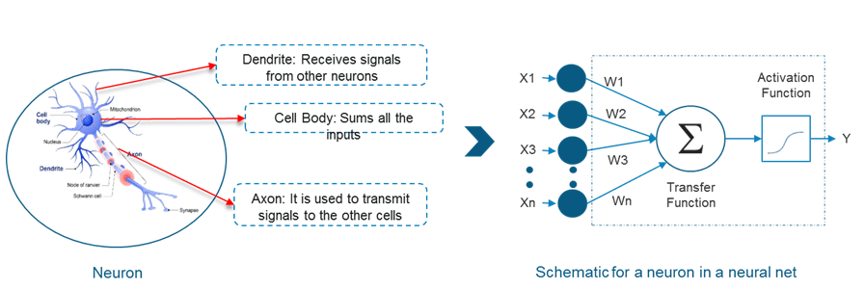

* If we focus on the structure of a biological neuron, it has dendrites which is used to receive inputs. These inputs are summed in the cell body and using the Axon it is passed on to the next biological neuron as shown in the above image.
* Similarly, a perceptron receives multiple inputs, applies various transformations and functions and provides an output.
* As we know that our brain consists of multiple connected neurons called neural network, we can also have a network of artificial neurons called perceptrons to form a Deep neural network. So, let’s move ahead in this Deep Learning Tutorial to understand how a Deep neural network looks like.